Lancashire SEND  Specialist Teacher Resources  Home learning ideas for pupils with Special Educational Needs | The Coronavirus pandemic means that parents and carers of young people with SEND are facing uncertainty. We know schools are on the front line and are playing a hugely important role in keeping communities going in these challenging times. With lots of parents having to teach SEND pupils at home we thought we would send you a weekly themed resources that you can share with your teachers and parents.

Home Learning
In the coming weeks we hope to cover a range of topics that would be suitable for children with a range of learning needs. The topics will vary but will cover broad areas of cognition and learning, communication and interaction, social and emotional wellbeing and sensory and physical needs. We welcome any feedback from parents and carers.
Getting Started  - Have a daily plan – include your child's interests and motivators  - Flexibility – be prepared to change the plan  - Chunk activities with a practical, movement break between. | - Developing life skills is also learning.  - Incorporate a range of tools to engage learning e.g. books, apps, garden, household objects.  - Remember every young child can learn, just not on the same day or in the same way.

burn to the hand may appear to go unnoticed (hyposensitivity).

Sensory ideas and resources for home learning

Overview

Our senses are essential in order for us to function and participate in the world. They provide us with unique experiences and enable us to interact with those around us. Our senses help us make sense of our environment and how to respond within it and they play a significant role in determining our actions.

Activity 1.Salt Trays

Children of all ages and abilities can benefit from this great kinesthetic activity. It emphases multisensory learning and how important it is. When children learn with all their senses, they are far more likely to remember what they learn.
Salt trays are perfect for practicing these skills:
- Handwriting, basic letter formation, and fixing letter reversals
- Writing the phonograms from dictation
- Sight words
- Spelling words

https://blog.allaboutlearningpress.com/salt-trays/ Use this link to find out more information.

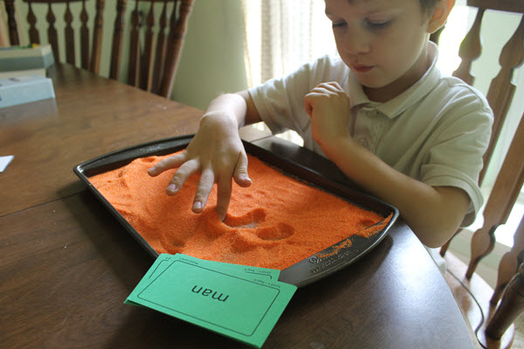

Activity 2.Sensory circuits structure:
A circuit runs in 3 sections, based on the theories of sensory processing and sensory integration and the practical consideration of providing a structured sensory motor input.
1. Alerting section – to provided vestibular stimulation (allowing fluid in the ears to move about through jumping and head movement), preparing the brain for availability for learning and for the demands of the school environment
2. Organising section – activities that require multi-sensory processing and balance. The individual needs to organise their body, plan their approach and do more than one thing at a time in a set sequential order. Activities such as climbing, hopping, balancing, looking and throwing into a target, hone skills that increase focus, attention span and performance within the classroom setting.
3. Calming section – this is very important to provide input to ensure that as children leave the circuit and enter the classroom they are as calm and centred and ready for the day as possible.
Examples of sensory circuit activities are:
• Skipping with a rope – individual or rope turned by others or French skipping
• Trampette bounce
• Crash landing – jumping form a trampette onto a crash mat of jumping from high place to low place
• Space race – jumping around course of cones on a space hopper
• Bouncing sphere – bouncing seated on an exercise/fit ball
• Jogging on the spot
• Jumping jacks from crouched position back to crouch
• Hopscotch
• Hoop-la – standing in a hoop and rotating
• Step ups – stepping up and down on a solid bench or platform
• Logroll – roll along line of gym mats, commando crawl
• Balance obstacle course
• Rolling ball – with tummy down on fit ball, walk hands out and back again
• Hand over hand pull – pulling self along using rope attached to wall bars
• Simon says sequences
• Gymnastic ribbon exercises
• Balancing on a wobble board
• Press ups
• Pilates plank exercise
• Crawling
• Ball squash – child lies on a mat and fit ball is rolled slowly up and down the child by an adult, using maintained and constant pressure to calm

Activity 3. Make your own Lava lamp
Equipment
- A clear plastic bottle or jar
- Some water
- Food colouring or poster paint
- Vegetable or sunflower oil
- Alka-Seltzer tablets or baking powder
Instructions
- Put some water in the bottom of the bottle along with a few drops of food dye or a squirt of paint.
- Carefully add the oil, stopping at least 3 cm from the top of the bottle.
- Ask an adult to help break the Alka-Seltzer into pieces (or use a teaspoon of baking powder) and start adding theme to the bottle. Remember to leave the lid off!
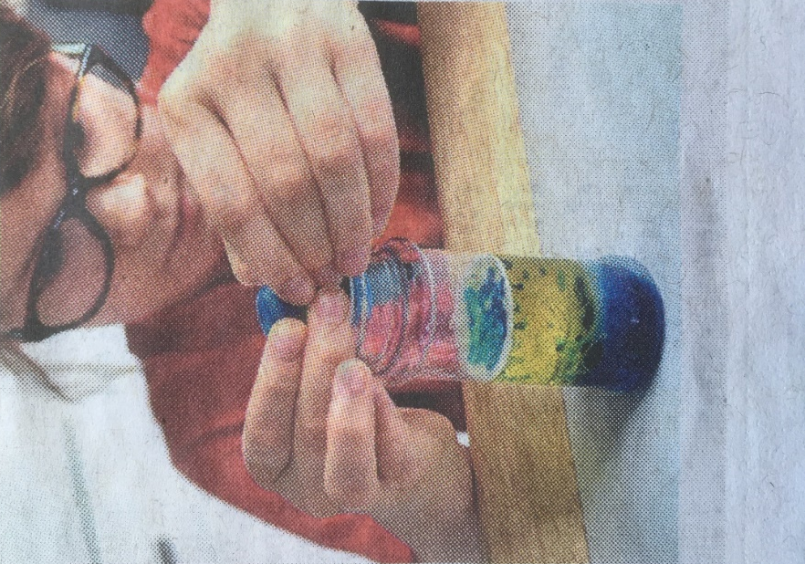

- Watch as the coloured bubbles rise and sink back down – like wax in a lava lamp.
- Once it stops bubbling, you can repeat the experiment immediately or put the lid on and keep it for later.
The Science
- Oil and water don't mix – the fancy science word is "immiscible."
- Oil floats on top of the water because it has a lower density.
- The carbon dioxide produced by the Alka-Seltzer has the lowest density and rises to the top, carrying some of the coloured water with it – as if the water temporarily has a buoyancy jacket.
- When the water and the carbon dioxide reach the surface of the oil, the bubble pops, releasing the carbon dioxide in to the atmosphere and the water then sinks back below the oil.

Activity 4
Make your own play dough
Ingredients
Serves: 4
250g plain flour
50g salt
140ml water
1 to 2 tablespoons cooking oil
Few drops food colouring (optional)

Method
Prep: 1hour Ready in:1hour
- Mix together the flour and salt in a large mixing bowl. Add the water and oil.
- Knead well until mixture is smooth about 10 mins. You might need to add a bit more flour or water until the consistency is smooth but not sticky.
- Add food colouring and knead until the colour is fully blended.
- Store in a plastic bag in the refrigerator until chilled enough to use.

Activity 5

Ice Block Treasure Hunt
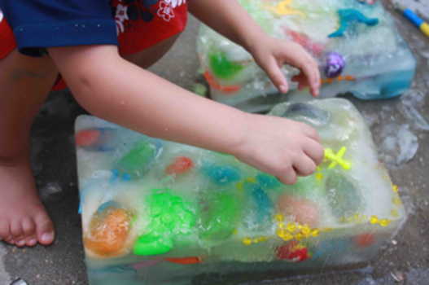
Materials:
- plastic container or bowl
- water
- small toys: plastic animals or dinosaurs, tops, rubber balls, shells, coins (for older children), etc
- optional: ice cube tray, food coloring and water to make colored ice
- warm water, spray bottles, paintbrushes, salt, a hammer --anything that you or your child may think of that could be used to get the toys out of the ice block
What to do:
-(Optional) Make and freeze coloured ice cubes using the food colouring and water
- Fill the plastic container with about an inch of water. Add three or four toys and some coloured ice cubes and freeze.
- When the first layer is frozen solid, add more water and a few more toys and ice cubes. Repeat this process until your container is full and you have a solid block of ice. It may take a couple of days to create your ice block.
- Remove the ice block from the plastic container.
- Give the kids some of the supplies for excavating the toys from of the ice. You could start by giving them spray bottles, paintbrushes, spoons and water. Then give them the salt and hammer for last.
- Let your kids have fun exploring and experimenting with the ice block and tools. They'll enjoy the process of discovering and digging out their treasures.
Take extra care if you choose to allow your children to use a hammer, especially if you are doing this project with more than one child. Another note-- we broke a couple of necklaces and a few other items that were made of harder, less flexible plastic. There's a chance that some of the small toys could get broken, so be sure to use toys that you and your child won't miss. Happy exploring!
Activities from Twinkle
Twinkle has a plethora of fun and engaging activities including activity cards, messy play, sensory bottles etc. please click on the link below:
https://www.twinkl.co.uk/search and search 'send sensory home learning'

