OUR BOOKS OF THE WEEK

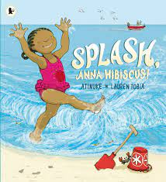 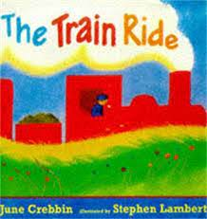 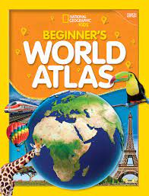

KEY VOCABULARY

|  |  |  |  |
| --- | --- | --- | --- |
| General | Map, globe, world, country, city, town, village, street, cul-de-sac, local, abroad, earth, language | Homes | House, flat, bungalow, caravan, boat |
| Transport | Aeroplane, car, boat, travel, bus, train, tram, walk, distance | Countries/Continents | UK, Great Britain, island, England, Ireland, Scotland, Wales, France, Africa, China, America, Poland |
| Climate | Hot, cold, dry, humid, wet |  |  |

THERE’S NO PLACE LIKE HOME

WHAT WE ARE LEARNING ABOUT

WE WILL:

* THE PLANET WE LIVE ON
* THE WORLD MAP
* THE DIFFERENCE BETWEEN COUNTRIES AND CULTURES AND TO BE RESPECTFUL OF OTHERS.
* LOOKING AT HOW CLIMATES DIFFER IN COUNTRIES AROUND THE WORLD.
* EXPLORING FAMOUS LANMARKS
* LOOKING AT DIFFERENT MODES OF TRANSPORT
* COMPARE DIFFERENT LOCALITIES AND PLACE WE LIVE.
* BECOMING FAMILIA WITH OUR OWN COUNTRY AND WHAT WE ARE KNOWN FOR
* BE COMPARING OUR LIVES AND TRADITIONS TO OTHERS AROUND THE WORLD.

MATHEMATICAL DEVELOPMENT

WE WILL BE:

-Developing knowledge on numbers 20 and beyond recognising patterns and similarities

-Addition and subtraction

-Exploring shapes

YOU CAN HELP AT HOME BY:

-practice my counting forwards and backwards to 20 and beyond

-PRACTICE ADDING AND SUBTRACTING ONE

EYFS CURRICULUM LEAFLET



PERSONAL, SOCIAL & EMOTIONAL DEVELOPMENT

WE WILL BE:

-TO NEGOTIATE WITH OTHERS FAIRLY AND MANAGE OUR EMOTIONS APPROPRIATELY.

-FOCUS ON SHARING WITH OTHERS AND TAKING TURNS

YOU CAN HELP AT HOME BY:

-ENCOURAGING ME TO SHARE THINGS.

LITERACY

WE WILL BE:

STARTING FORM LETTERS CORRECTLY AND CONFIDENTLY TO WRITE SUPPORTED WORDS AND SENTENCES.

-LEARNING TO FIND INFORMATION FROM BOOKS

YOU CAN HELP AT HOME BY:

-SHOW ME HOW TO FIND INFORMATION IN NON-FICTION BOOKS.

UNDERSTANDING THE WORLD

WE WILL BE:

-Exploring different cultures and communities around the world

-Looking at different countries around the world and comparing them to where we live

YOU CAN HELP AT HOME BY:

-ASK ME ABOUT WHAT I HAVE BEEN LEARNING.

EXPRESSIVE ARTS

WE WILL BE:

-LISTENING TO MUSIC FROM AROUD THE WORLD

-EXPLORING THE WORKS OF MANY ARTISITS FROM AROUND THE WORLD DISCCUSING IF WE LIKE THEIR ART AND INTERPRETING DIFFERENT STYLES INTO OUR OWN WORKS.

YOU CAN HELP AT HOME BY:

-HELP ME TO LOOK AT DIFFERENT ARTISTS AND THEIR WORK FROM AROUND THE WOLD.

LANGUAGE & COMMUNICATION DEVELOPMENT

WE WILL BE:

-TALKING ABOUT SIMILARITIES AND DIFFERNCES OF OUR OWN LIVES, CULUTURE, COUNTRY AND TRADITIONS IN COMPARISON TO OTHER CHILDREN AROUND THE WORLD.

YOU CAN HELP AT HOME BY:

-ASK ME ABOUT WHAT I HAVE LEARNT DURING THIS TOPIC.

PHYSICAL DEVELOPMENT

WE WILL BE:

-LEARNING TO FORM LETTERS NEATLY AND WRITE ON LINES.

-LEARNING TRADITIONAL DANCES FROM COUNTRIES AROUND THE WORLD.

YOU CAN HELP AT HOME BY:

-HELPING ME TO FORM MY LETTER CORRECTLY BY CHECKING OUR WEBSITE FOR VARIOUS LINKS TO SHOW US.