OUR BOOKS OF THE WEEK

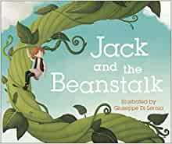 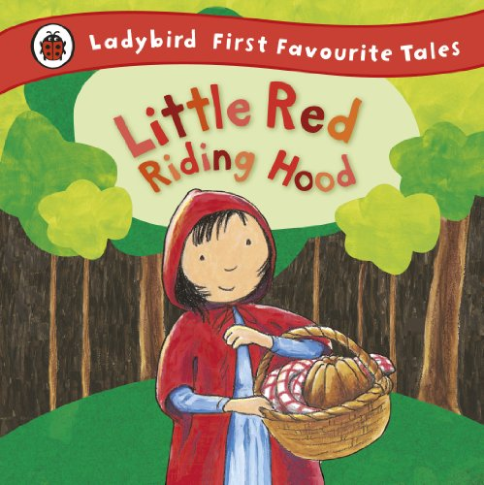 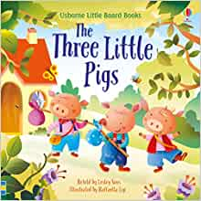 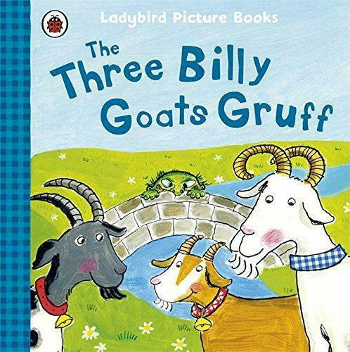 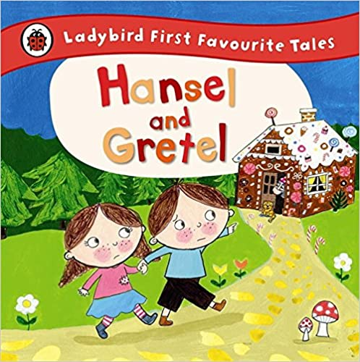

KEY VOCABULARY

|  |  |  |  |
| --- | --- | --- | --- |
| Story Language | Once upon a time  Long ago  Faraway  Happily ever after | Settings | Castle, forest, palace, cottage, woods, |
| Characters | Queen, king, princess, prince, villain, ogre, hero, wizard, witch, handsome, charming, wicked, giant, beautiful, grumpy, angry, gloomy | General | Wish, curse, storytelling, moral, magic, promise, spell, marriage |

ONCE UPON A TIME

WHAT WE ARE LEARNING ABOUT

WE WILL BE:

● Reading a range of different stories and fairytales

● Exploring different settings and characters

● Looking at morals from stories

● Comparing fairytales from around the world

● Using ipads to retell and sequence stories

● Writing and creating our own stories and alternative endings

● Roleplaying and hot seating various fairytale scenarios

● Designing our own story puppets, settings and props

● learning classic nursery rhymes

● Building settings using junk modelling and construction.

EYFS CURRICULUM LEAFLET

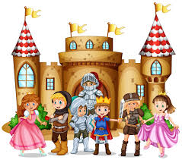

RECEPTION CLASS

SPRING 1

MATHEMATICAL DEVELOPMENT

We will be learning:

● Numbers within 20

● To explore problem solving.

● Doubling and halving

You can Help Me At Home By:

● Practising 1:1 correspondence when counting to 20

● Helping me recognise numbers to 20.

● Practising sharing into two groups to introduce the concept of halving.

LITERACY

We will be:

● Reading a range of traditional tales, retelling and sequencing different stories and describing characters and settings.

● Exploring alternative versions and endings to classic tales,

You can help me at home by:

● practising reading short stories and supporting me to write my own stories.

UNDERSTANDING THE WORLD

We will be learning how to:

● design and build bridges, rafts and houses and testing their effectiveness

● take pictures and videos of our own role-play and share them with others.

● Use apps such as ‘Puppet Pals’ to narrate our own versions of the stories.

You can Help Me At Home By:

● Sharing fairytales from around the world and comparing them.

EXPRESSIVE ARTS

We will be learning how to:

● Create our own story puppets and props and use them in our play.

● use our imagination to retell stories using green screen, puppets and props, We will use music to change the mood of our stories and build sets for our stories using construction materials.

You can Help Me At Home By:

● Providing opportunities for me to dress up and tell my own stories.

PERSONAL, SOCIAL & EMOTIONAL DEVELOPMENT

We will be learning how to:

● discuss good and bad characters through storytelling and why their actions make them good or bad. We will think about the lessons that we can learn from stories to help us make our own positive choices.

You can Help Me At Home By:

● Explore stories and tales with morals.

● Talk to me about good and bad choices i can make at school and at home.

LANGUAGE & COMMUNICATION DEVELOPMENT

We will be learning how to:

● RESPOND TO ‘HOW’, ‘WHERE’ AND ‘WHY’ QUESTIONS AROUND STORY.

●

You can Help Me At Home By:

● Explore stories and tales with morals.

● Talk to me about STORIES WE HAVE READ AND DIS

PHYSICAL DEVELOPMENT

Our sport coaches will be teaching PE every Friday. Please ensure your PE kit is in school.

We will be learning how to:

● enjoy movement and dance activities to act out stories, such as moving like a wicked witch, a princess, a pirate or an ugly troll.

● practise gross motor activities such as throwing, catching and balancing.