OUR BOOKS OF THE WEEK

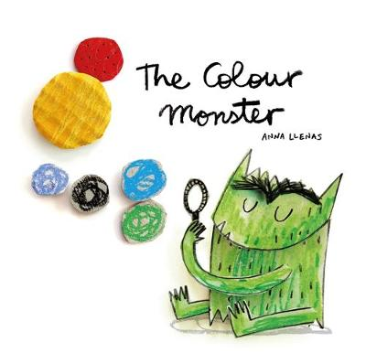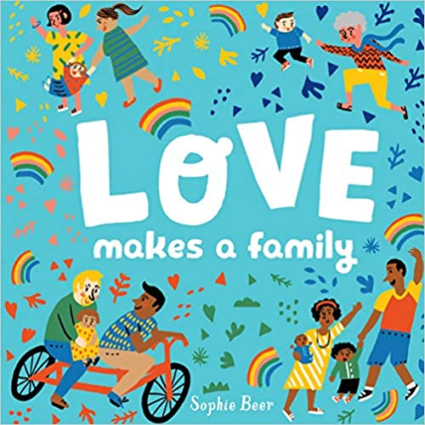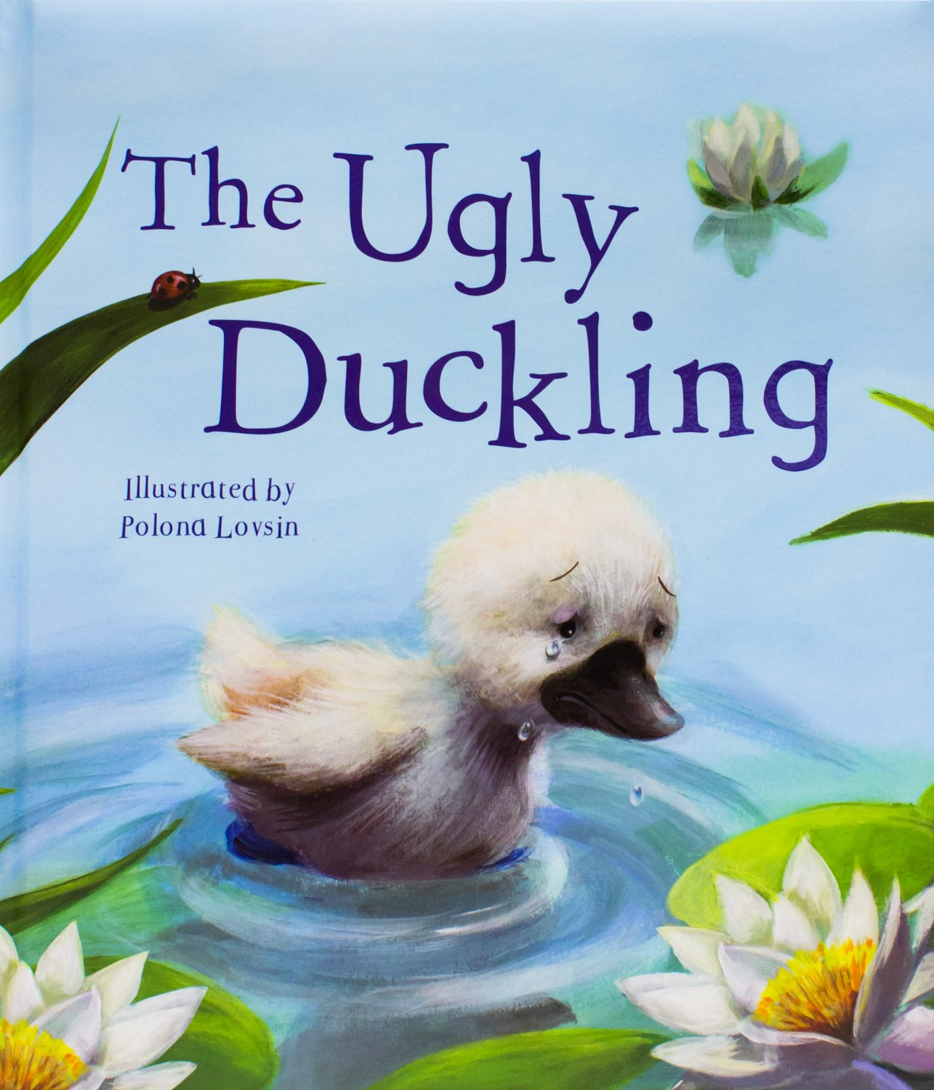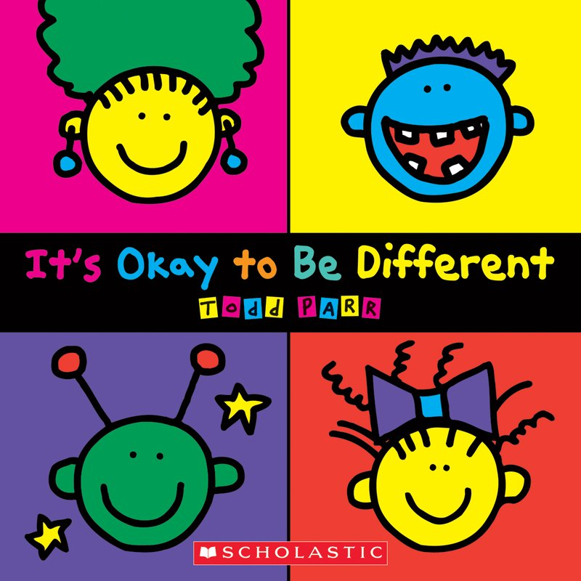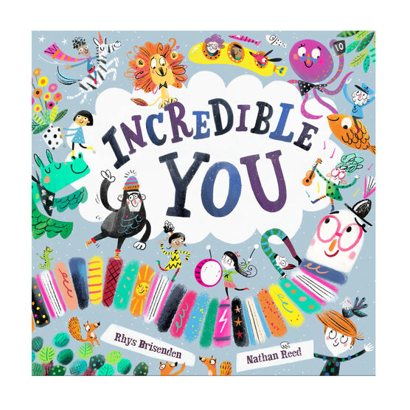

KEY VOCABULARY

|  |  |  |  |
| --- | --- | --- | --- |
| Feelings | Happy, sad, anxious, lonely, angry, worried, pleased, excited, surprised, embarrassed. | My Body | Skeleton, shoulders, knees, ankles, knees, eyes, nose, elbows, mouth, freckles, dimples, wrinkles, hair, chin forehead. |
| Families | Mother, father, brother, sister, son, daughter, grandfather, grandmother, cousin, aunty, uncle, step-father, step-mother | Growing Up | Baby, toddler, child, teenager, adult, |
| Senses | Sight, hear, touch, hear, taste | Inspiring People | Inspiring, determined, success, failure, dreams, ideas, self-worth, self-belief, self-love. |

INCREDIBLE ME

WHAT WE ARE LEARNING ABOUT

WE WILL BE:

* LEARNING ABOUT THE DIFFERENT PARTS OF OUR BODIES
* TALKING ABOUT SIMILARITIES AND DIFFERENCES BETWEEN OURSELVES AND OTHERS
* UNDERSTANDING AND TOLERATING OTHERS
* READING AT STORIES FROM OTHER CULTURES, PAST AND PRESENT.
* LEARNING TO DESCRIBE OUR FEELINGS.
* LEARNING ABOUT KEEPING OUR BODIES HEALTHY
* OBSERVING CHANGES AS WE GROW
* LEARNING ABOUT DIFFERENT TYPES OF FAMILIES.
* ROLE PLAYING DOCTORS
* MAKING TIMELINES
* LEARNING ABOUT PEOPLE WHO MADE BIG IMPRESSIONS ON OUR WORLD.
* BELIEVING IN OURSELVES
* THINKING ABOUT THINGS WE WOULD LIKE TO ACHIEVE IN OUR LIFETIMES.

EYFS CURRICULUM LEAFLET

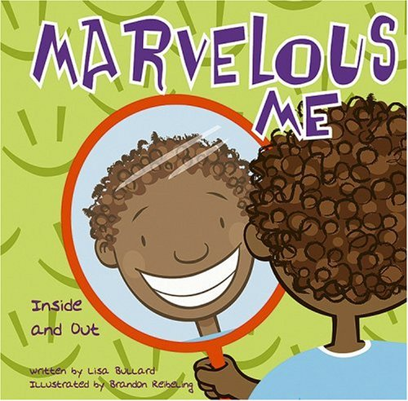

RECEPETION CLASS

AUTUMN 1

MATHEMATICAL DEVELOPMENT

WE WILL BE:

ROTE COUNTING TO 10

USING ONE-TO-ONE CORRESPONDANCE

TO COUNT ACCURATELY.

YOU CAN HELP AT HOME BY:

-COUNT OBJECTS WITH ME ACCURATELY

-COUNT FORWARDS AND BACKWARDS TO 10

LITERACY

WE WILL BE:

-LISTENING TO STORIES

-RESPONDING TO QUESTIONS ABOUT STORIES

-ASCRIBING MEANING TO MARKS WE MAKE

YOU CAN HELP AT HOME BY:

-READ ME STORIES FROM OTHER CULTURES AND DISCUSS THEM WITH ME.

UNDERSTANDING THE WORLD

WE WILL BE:

CONSIDERING SIMILARITIES & DIFFERENCES IN PEOPLE SUCH AS ETHNICITY, RELIGSION, GENDER AND CULTURE.

YOU CAN HELP AT HOME BY:

-TALK TO ME ABOUT OTHER CULTURES AND BELIEFS.

EXPRESSIVE ARTS

WE WILL BE:

-EXPLORING MEDIA AND MATERIALS

-HANDLING EQUIPMENT APPROPRIATELY & SAFELY.

YOU CAN HELP AT HOME BY:

-PROVIDE OPPORTUNITIES FOR ME TO EXPRESS MYSELF WITH THINGS THAT INTEREST ME.

PERSONAL, SOCIAL & EMOTIONAL DEVELOPMENT

WE WILL BE:

-TRYING NEW ACTIVITIES

-BUILDING FRIENDSHIPS

YOU CAN HELP AT HOME BY:

-ENCOURAGE ME TO HAVE DREAMS, MODEL POSITIVE SELF TALK AND BELIEVE IN MYSELF.

-TALK TO ME ABOUT WHY RULES ARE IMPORTANT

LANGUAGE & COMMUNICATION DEVELOPMENT

WE WILL BE:

-LEARNING VOCABULARY TO EXPLAIN OUR FEELINGS.

-TALKING ABOUT OURSELVES.

YOU CAN HELP AT HOME BY:

-TALK TO ME ABOUT HOW I AM FEELING

PHYSICAL DEVELOPMENT

WE WILL BE:

-LEARNING TO HOLD A PENCIL

-WORKING ON OUR FINE AND GROSS MOTOR SKILLS

YOU CAN HELP AT HOME BY:

-TALK TO ME ABOUT MAKING HEALTHY LIFESTYLE CHOICES AND WHY IT IS IMPORTANT.